# CS 255 System Design Document Template

## UML Diagrams

### UML Use Case Diagram

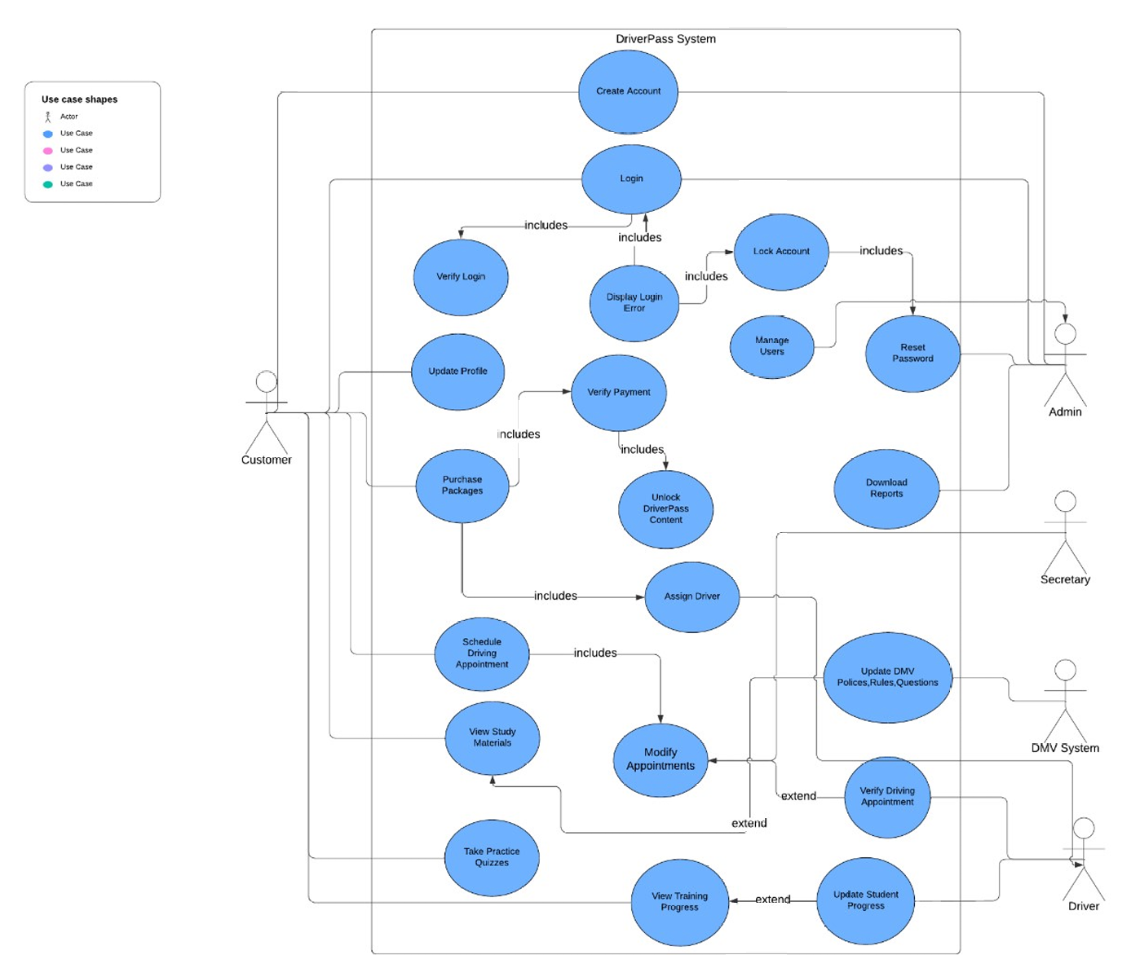

### UML Activity Diagrams

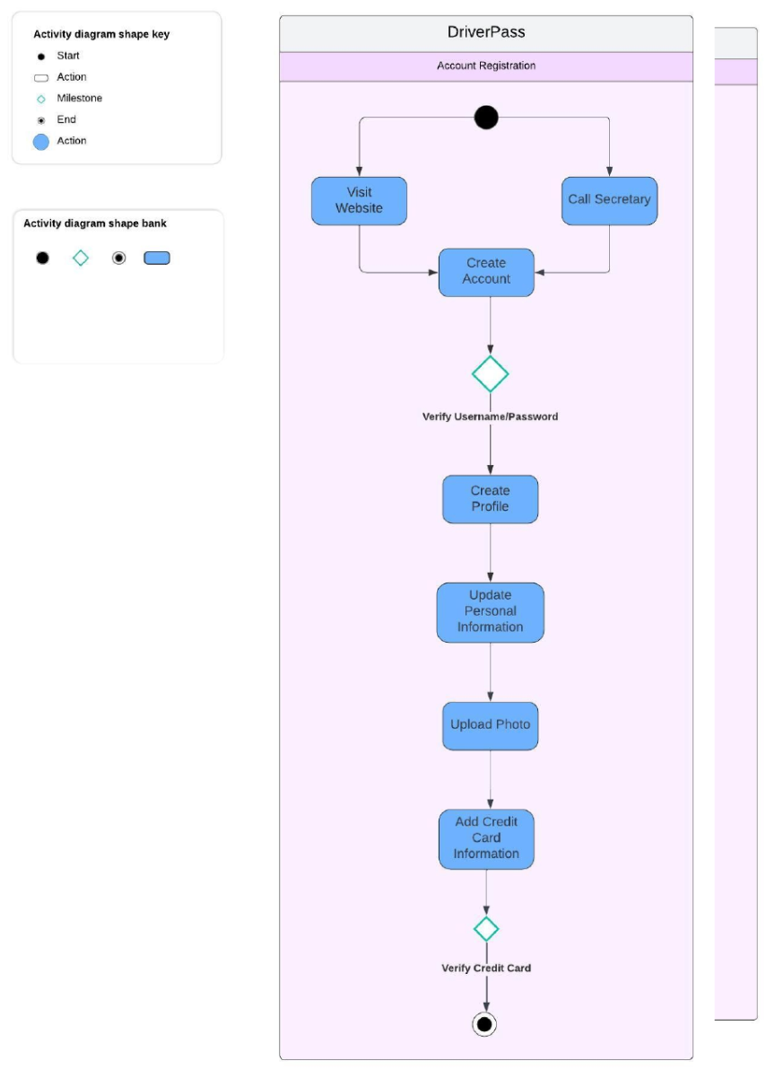

### UML Sequence Diagram

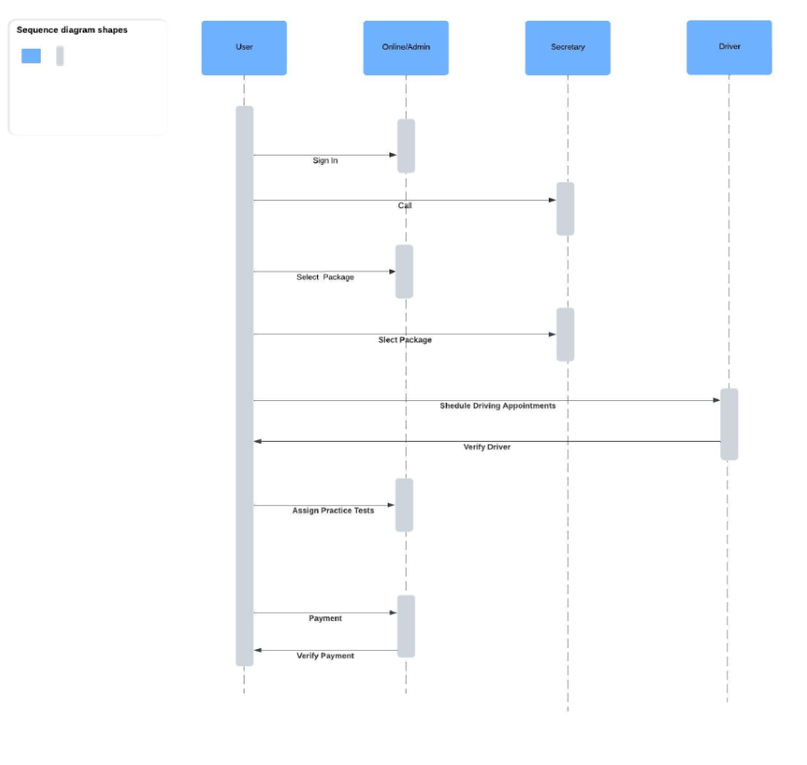

### UML Class Diagram

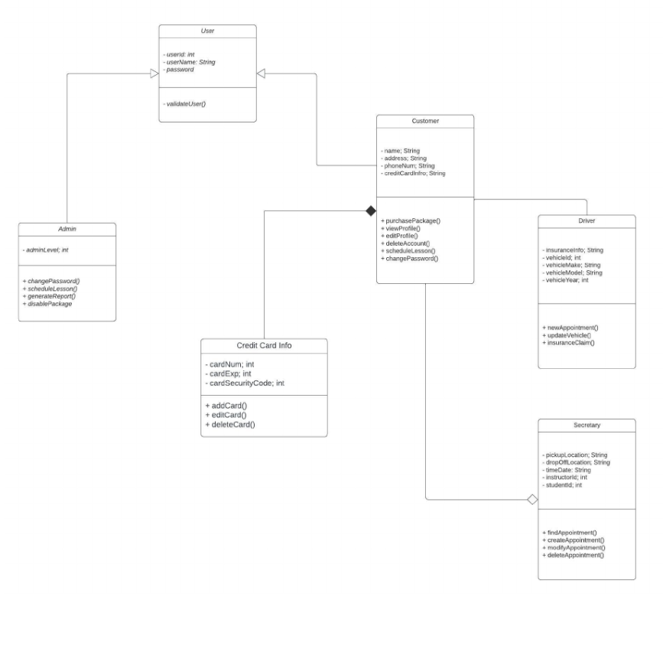

## Technical Requirements

The hardware requirements for the user’s computer must support a basic web interface. While the application is not highly advanced, it should run on modern hardware. Since the application is being developed in 2024, users should have at least Windows 10 or a recent version of macOS to ensure compatibility with newer interface features.

Security is one of the most critical technical requirements. As DriverPass will handle sensitive customer information, including credit card details, robust security measures are essential. Two-factor authentication and the use of complex, unique passwords are necessary to safeguard user data. Additionally, data should be backed up on the cloud to protect against potential cyberattacks or system failures, ensuring data integrity and availability.

Another important aspect is the system’s back end. DriverPass should have a dedicated developer to provide customer support and regularly update the user interface. These updates will help maintain an optimal user experience and keep the system running smoothly. While the focus of the diagrams was on functional requirements, technical requirements such as security and back-end support could be represented in a separate diagram. The IT department and administration will play a vital role in implementing and maintaining these technical features, ultimately driving business growth and attracting more users.